**Create a database in cloudant DB**

|  |  |
| --- | --- |
| Team ID | PNT2022TMID36343 |
| Project Name | Smart waste management system for metropolitan cities |

Step 1: login into IBM CLOUD account

Step2: On the top left corner click on RESORCE LIST

Step 3: Search for Database option then click on drop down arrow

Step 5: Now, cloudant window appears then click on launch dashboard on right corner

Step 6: click on create database on right corner then provide the name for database and check the

-

partitioned -

recommended for most workloads>

option then click on create

Step 7: Finally, cloudant DB was successfully created.

**Screenshots of cloudant account:**

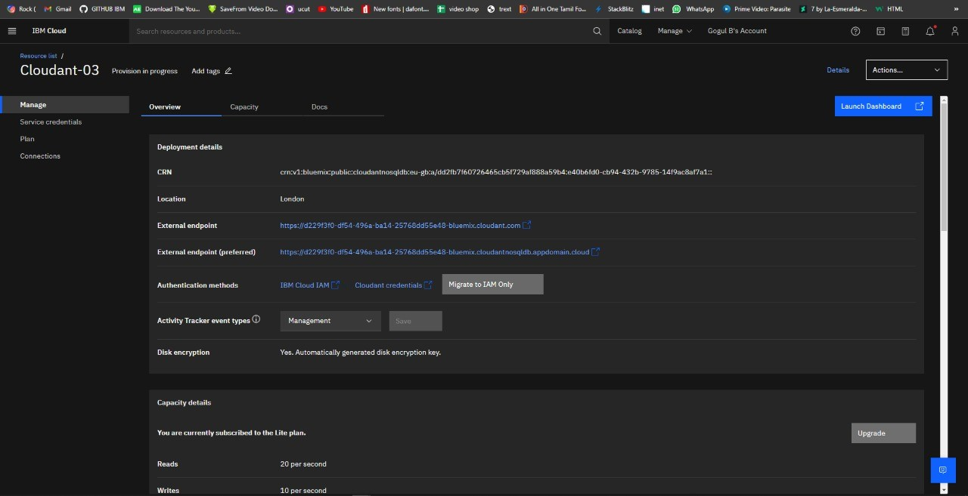

Step 4: Then click on cloudant account available

[k](http://cbs.wondershare.com/go.php?pid=5239&m=db)

Remove Watermar



Wondersh

~~ar~~

[~~e~~](http://cbs.wondershare.com/go.php?pid=5239&m=db)

PDFelemen

[t](http://cbs.wondershare.com/go.php?pid=5239&m=db)

[k](http://cbs.wondershare.com/go.php?pid=5239&m=db)

Remove Watermar



Wondershar

[e](http://cbs.wondershare.com/go.php?pid=5239&m=db)

PDFelemen

[t](http://cbs.wondershare.com/go.php?pid=5239&m=db)

